**Introduction/Business Problem**

Mumbai, India being the financial hub of India, attracts lots of people who are trying to expand their business. Now, if a food chain is thinking to open a new Italian restaurant in this city, it could be a problem for them to decide the best location. So, in this report we are going to help Management of an established food chain who are trying to expand themselves in Mumbai and are looking for the best location to open a restaurant.

Here, our stakeholders will be this established food chain. We will help them identify best location for their business depending upon their requirements. Like, if they prepare a specific type of cuisine, what will be the best location for them so that they can make profits?

**Data Section**

In this problem we are going to use foursquare location data to analyze the best location in city of Mumbai, India. Foursquare provides the wide range of, exposed, easy to use API’s. In order to solve this problem, we will analyze Italian restaurants that are popular in which areas and hence will conclude which location suits best in our case.

**Methodology**

In order to solve this problem, we have used the data provided by foursquare API’s. We have gathered the location data already collected by foursquare team. Then for every location we have identified, what all Italian Restaurants are present in the City. After we have identified all the restaurants, we have explored each and every restaurants collecting there ratings. Since rating play an important role in identifying the location and popularity, we have taken this variable into account to identify the best or suitable location to open the restaurant. Once all the restaurants with ratings are collected, we have sorted the restaurants in ascending order based on the ratings.

This sorting helps us identify the least or average rated Italian restaurants making the least rated as the first one in the list. Now from this list, we can have top 3 Italian restaurants concluding that the people love to eat Italian at those locations but, already present Italian restaurants are not giving them good experience which is evident from average or low ratings. Thus those locations can be a potential option for opening a new Italian restaurant.

**Results**

We have found that there are few areas where people are looking for Italian restaurants but the restaurants at these locations are not up to the mark of the customers thus resulting in an open area for new food chains to come in and expand their businesses there.

Below we can see areas on map where Italian restaurants are present.

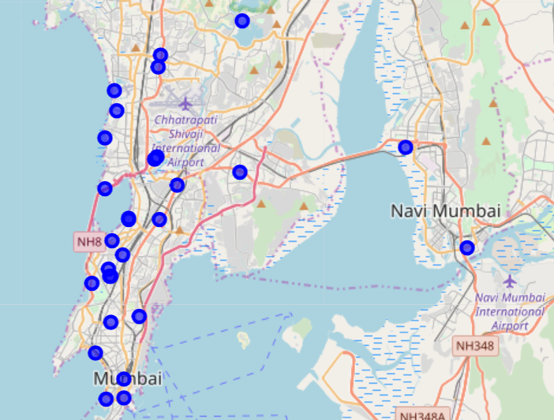

Then we have identified the potential areas where opening a restaurant can be profitable since these areas are no having highly rated Italian restaurants unlike others.

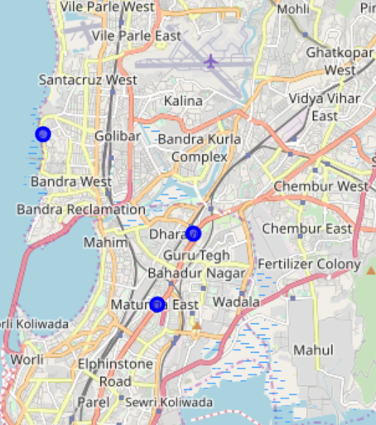

**Discussion**

In the city of Mumbai, there are many locations where Italian restaurants are working and operational. But the main question arises what will be the best or potential location to open a new restaurant. For an Italian food chain who wants to expand themselves in this city this could be a challenging thing. So in order to help them, we have come up with a solution where we are suggesting them three locations (as shown in map above ) from where they can start opening the restaurant. Major variables that we have taken into account are “Ratings” given by the customers to the restaurants.

A restaurant runs successfully only if that satisfies the customer. Thus considering this as the major factor, we have then found the least or average rated Italian restaurants in Mumbai. These areas signifies that the people come here to eat Italian food but restaurants are lacking good Italian food, which is evident from the ratings. Thus, we can conclude that these areas clears as the potential candidate for good location where Italian restaurant if opened will run into profit.

**Conclusion**

Although there can be other possible ways which can help us identify the good locations for the Italian restaurants, but the one identified in this can be could to start with. **We have three locations where food chain can open an Italian restaurant.** We have considered “Rating” as the major factor for finding the location. While there can be other factors that can be considered like “localities”, “price of the area”. Since we have worked on already collected data provided by foursquare API, we have used only “rating” as the variable.